Items of Note

Chapter member Andrew Walker was awarded the Ed Payne Young Engineer of the Year award at the 76th Annual International Conference held in Montreal. Congratulations Andy!

The Chapter website is now available. The link can be found on the Chapter page of the SAWE site.

W

**Social Cookout: July 14th**

Please join us for the Mojave Desert Social Cookout. Families are invited and there is a pool for swimming.

RSVP to Megan Derrig.

**Business Meeting: August 17th**

Guest Speaker: Andy Walker

Upcoming Events

Patch 1 Patch 2

Submitted Logos

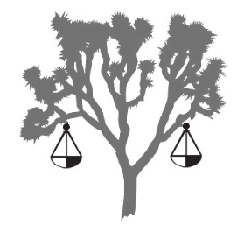  

Submitted Patches

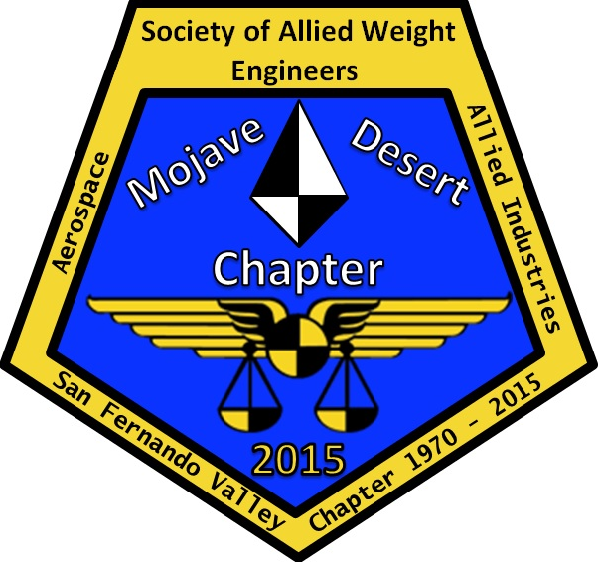 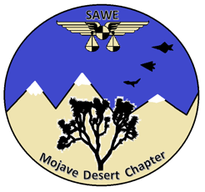

Logo 1 Logo 2 Logo 3

Logo Competition

The submitted logos and patches are included below. Please submit your vote for your preferred logo and patch to Megan Derrig by July 14th. The current submissions do not have to be the final design. If you have suggestions for changes please submit those along with your vote. We will be stuck with this logo for a while so feedback is encouraged and welcomed.

**SAWE Mojave Desert Chapter**

**Newsletter – June 2017**

Previous Chapter Meeting Summary

The June meeting was held on June 13th at Gino’s in Lancaster. The primary topics were the conference report provided by Director James Valentine and the submitted logos. The meeting minutes are available on the Chapter website for review.